Curriculum Vitae (CV)

Title | Dr. | First Name | Jagpal | Last Name |  | Singh | Photograph
Designation |  | Assistant Professor( Ad hoc) |  |  |  |  | 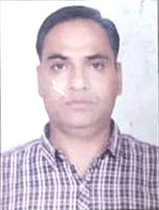
Department |  | Political Science
Address  (Campus) |  | SPM College,West Punjabi Bagh,Delhi-110026
Phone Number(Campus) |  | 011-25224499
Fax |  | 25221672
Email |  | Dr,jagpalsingh.js@gmail.com/jagpal@spm.du.ac.in
Education |  | P.hd.
Subject |  | Institution |  |  | Details
BA(H) Pol Sci |  | MDU( Rohtak) |  |  | Passed in 1994 and Secured 50.75%
MA(Pol Sci) |  | KU(Kurukshetra) |  |  | Passed in 1996 and secured 55.12%
M.Phil.(African Studies) |  | DU(Delhi) |  |  | Passed in 1999 and secured 58%
Research Interests/ Specialization
International Relations/Organisations/African /Conflict Management and peace Studies.

Teaching Experience
7
Publications:NA
Chapters in Edited Books:NA

Research Papers in Journals:NA
Participation in International Conferences/Workshops: NA

Workshops:.NA
Innovative Projects:NA

Awards/Recognition:NA

Other Responsibilities:NA

