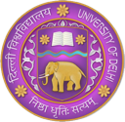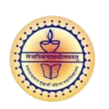

Curriculum Vitae (CV)

Title | Mr. | First Name | Harshvardhan | Last Name | Arya |  | Photograph
Designation |  | Assistant Professor |  |  |  |  | 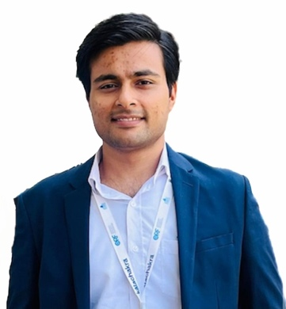
Department |  | Political Science
Address  (Campus) |  | Department of Political Science, Shyama Prasad Mukherji College for Women (University of Delhi), West Punjabi Bagh, Delhi, 110026
Phone Number (Campus) |  | +918010793104
Fax
Email |  | harshvardhan6471@gmail.com
Education |  | B.A. (H) Political Science, M.A., M.Phil.
Degree |  | Institution |  |  |  | Year
Ph.D. |  | Department of Political Science, University of Delhi |  |  |  | Pursuing
M.Phil. |  | Department of Political Science, University of Delhi |  |  |  | 2022
M.A. |  | Department of Political Science, University of Delhi |  |  |  | 2018
B.A. (H) |  | Atma Ram Sanatan Dharma College, University of Delhi |  |  |  | 2016
Research Interests/ Specialization
- Ancient and Medieval Indian Political Thought
- Political Philosophy
- Indian Government and Politics
Teaching Experience
- Since February, 2024
Assistant Professor, Shyama Prasad Mukherji College for Women, University of Delhi.
- From January, 2023 to February, 2024
Guest faculty, Satyawati College (Eve.), University of Delhi, Delhi.
- From October to November, 2022
Guest faculty, SOL, Daulat Ram College Centre, University of Delhi, Delhi.
- From April to July, 2022
Guest faculty, NCWEB, Kalindi College Centre, University of Delhi, Delhi.
Publications:
Chapters in Edited Books:
Research Papers in Journals:
Participation in International Conferences/Workshops:
Conference/ Seminar Presentations:
2024
- ‘Exploring the Self in the ideas of Deen Dayal Upadhyaya: Individual as a Catalyst of change,’ presented in National Seminar on Relevance of Pandit Deen Dayal Upadhyaya's Philosophy In Contemporary India at National Democratic Teachers' Front, Pt. Deen Dayal Upadhyaya Study Circle, University of Delhi.
- ‘Educational Diplomacy and the Vision of Viksit Bharat: Cultural Connectivity and Knowledge Sharing between India and Southeast Asia,’ presented in International Seminar on India’s Culture-based Foreign Policy in South and Southeast Asia at Department of Political Science, University of Delhi.
2022
- ‘Concept of Samrastā (Social Harmony) in the Dharmaśāstra,’ presented in International Seminar on Revisiting the Ideas of India from ‘Swaraj’ to ‘New India’, at Department of Political Science, University of Delhi.
Workshops:
2024
- Presented as a speaker at The Young Scholars Workshop 2024, organized by Youth Ink, an initiative of SAFL India Foundation.
- 4-Week Faculty Induction/Orientation Programme (27th March to 23rd April, 2024) Organized by Teaching Learning Centre Ramanujan College, University of Delhi.
- One Week Orientation and Sensitization Programme (20th May to 30th May, 2024) Organized by Malaviya Mission Teacher Training Centre, Shri Ram College of Commerce, University of Delhi.
Innovative Projects:
Awards/Recognition:
- UGC – NET (2019)
Other Responsibilities:
- Member, Admission Committee (2024-25), Shyama Prasad College (for Women), University of Delhi.
- University Activities – Member of the various Question Paper Setting Board (2024), at Department of Political Science, University of Delhi.

