Curriculum Vitae (CV)
Title | Dr. | First Name | NEELAM | Last Name |  | 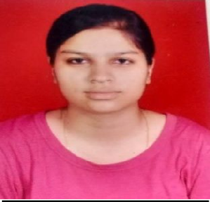  Photograph
Designation | ASSISTANT PROFESSOR
Department | HINDI
Address (Campus) |  | SHYAMA PRASAD MUHHARJI COLLEGE (FOR WOMEN), PUNJABI BAGH (WEST), NEW DELHI -110026
Phone Number (Campus) |  | 25224499
Fax | 25221672
Email | spmcollegedu@gmail.com
Education | Ph.D
Subject |  |  | Institution |  | Details
Ph.D |  |  | SUNRISE UNIVERSITY ALWAR (RAJ.)
Research Interests/Specialization
KATHA SAHITIYA
Teaching Experience
07 MONTHS (W.E.F 08.01.2024 TO TILL DATE)
Publications:
Chapters in Edited Books:
Research Papers in Journals: 1. HINDI SAHITYA ME PREMCHAND KA YOGDAN (COSMOS 2019) Vol. No 8, Page No 24, ISSN No. 2319-8966
2. HINDI BHASHA KI UPYOGITA (SAHITYA SAHITYA 2019) Vol. No. 5, Page No. 9, ISSN No. 2454-2695

Participation in International Conference/Workshops: 1. ROLE OF THE SOCI-ECONOMIC MANAGEMEN T AND TECHNOLOGICAL INNOVATIONS IN THE DEVELOPMENT OF INDIA ( 22 TO 23 DECEMBER 2018) IN DEPTT. OF RESEARCH
,SURISE UNIVERSITY, ALWAR (RAJ.) 2. INNOVATIVE
GREEN PRAXIS IN RESEARCH AND ACADEMICS :- A MULTI DISCIPLINARY APPROACH (14-15 DEC 2019) SUNRICE UNIVERSITY, ALWAR (RAJ.) 3. TEACHI NG IN INDIAN
LANGUAGE AND USEGE OF TECHNICAL TERMINOLOGY (8-9 APRIL 2024) AT SPM COLLOGE (FOR WOM EN) UNIVERSITY OF DELHI
Workshops:
Innovation Projects:
Awards/Recognition:
Other Responsibilities:

